F𝚛𝚘𝚖 𝙲𝚕𝚊𝚜𝚜 𝚋𝚊𝚜𝚎𝚍 𝙰𝚐𝚎𝚗𝚝𝚜 𝚝𝚘 𝚕𝚊𝚗g𝚌𝚑𝚊𝚒𝚗 𝙰𝚐𝚎𝚗𝚝s
As Artificial Intelligence (AI) systems evolve, the concept of Agentic AI — where AI systems are composed of modular, task-specific agents working collaboratively — has become a cornerstone of scalable and adaptable AI solutions. This blog explores the design considerations behind Agentic AI, examining how agents, tools, memory, state, and planning come together to create intelligent workflows. We’ll compare three implementations — CODE1, CODE2, and CODE5 — to shed light on the practicalities and complexities involved.
Press enter or click to view image in full size
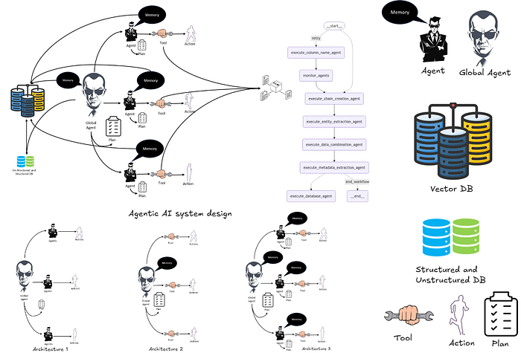
Architecture 1, Architecture 2, and Architecture 3, mapped to CODE1, CODE2, and CODE5 respectively.
The code can be found Here

Objective
The main objective of the provided code is to automate and streamline the extraction, transformation, and integration of structured data from unstructured textual reviews into a usable format for further analysis. Specifically, this workflow addresses the problem of entity extraction from customer reviews, associating extracted entities with existing structured datasets, and combining the two for comprehensive data analysis.
The problem being solved involves three key challenges:
- Unstructured Data Handling: Customer reviews often contain valuable information buried in natural language text. Extracting structured data like customer names and purchase dates from such reviews is critical for enriching existing datasets.
- Data Integration: After extracting relevant information, integrating it with structured datasets (e.g., customer transaction records) ensures a unified, comprehensive view of data for analysis.
- Automated Metadata Management: The solution not only extracts and integrates data but also generates and stores metadata for both structured and unstructured datasets. This facilitates a deeper understanding of the data, such as its statistical properties and potential quality issues.

Tasks
- ColumnNameAgent: Parses column name and description pairs into a structured dictionary.
- ChainCreationAgent: Sets up a chain using LangChain and a local LLM to perform Named Entity Recognition (NER) on review texts.
- EntityExtractionAgent: Applies the chain to extract entities from unstructured text in a dataset.
- DataCombinationAgent: Combines the extracted entities with an existing dataset to create an enriched dataset.
- DatabaseAgent: Stores the merged data into an SQLite database for further access.
- MetadataExtractionAgent: Extracts metadata, such as column details and data statistics, for analysis.
By leveraging advanced language models, database management, and structured workflows, this code enables businesses to automate and optimize their data processing pipelines, reducing manual effort and ensuring consistent, accurate data integration for decision-making.

The Role of Global Agents in Agentic AI
Global Agents are the central orchestrators in Agentic AI systems, ensuring smooth execution of workflows, coordinating agents or tools, and adapting dynamically to the state of the system. Below, we explore their role in CODE1, CODE2, and CODE5.

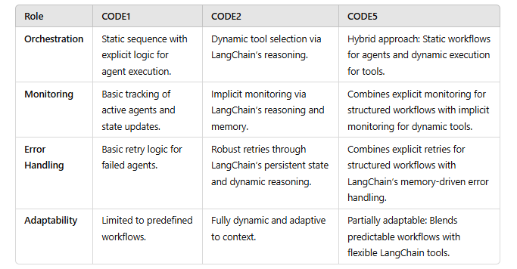
Global Agents in CODE1 focus on static, predictable workflows, while those in CODE2 embrace dynamic adaptability. CODE5 offers the best of both worlds, orchestrating structured agents while leveraging the flexibility of LangChain tools

Orchestration
The primary role of a Global Agent is to manage the sequence of task execution.
- CODE1: The Global Agent explicitly orchestrates a predefined workflow by sequentially invoking agents like ColumnNameAgent, ChainCreationAgent, and others. Each agent is hardcoded to perform specific tasks in a linear fashion.
- CODE2: Instead of explicit orchestration, the Global Agent leverages LangChain’s reasoning-driven dynamic execution. Tools are invoked adaptively based on inputs, observations, and the custom prompt (ZERO_SHOT_REACT_DESCRIPTION).
- CODE5: Combines explicit orchestration for structured workflows with dynamic LangChain tools. The Global Agent coordinates both explicit agents and tools for hybrid workflow execution.

Monitoring
Monitoring the progress and state of the workflow is essential for reliability and debugging.
- CODE1: The Global Agent performs basic monitoring by tracking which agent is active and updating the state explicitly after each task.
- CODE2: Monitoring is less explicit, as LangChain’s agent inherently handles observation and reasoning between tasks. The Global Agent primarily ensures the dynamic flow of tool execution.
- CODE5: Integrates both explicit and implicit monitoring. Structured agents track progress in explicit workflows, while LangChain tools provide reasoning and feedback in adaptive workflows.

Error Handling
Global Agents play a crucial role in handling errors and ensuring task completion.
- CODE1: Basic error handling relies on retry logic embedded in the workflow. If an agent fails, the Global Agent may attempt to re-execute the task up to a specified limit.
- CODE2: LangChain’s memory and reasoning framework simplify error handling. Persistent state allows the Global Agent to retry tools seamlessly without requiring explicit logic.
- CODE5: Combines structured retry logic for explicit agents with LangChain’s robust error-handling for tools. This hybrid approach ensures resilience across static and dynamic workflows.

Adaptability
A Global Agent determines the next step dynamically or based on pre-defined rules.
- CODE1: Limited adaptability, as the workflow is hardcoded and follows a static sequence.
- CODE2: Fully adaptable through LangChain’s dynamic reasoning. The Global Agent selects tools based on context and custom prompts.
- CODE5: Partially adaptable. Structured workflows provide predictable behavior, while LangChain tools add flexibility to handle varied inputs.

The Role of Agents and Tools in Agentic AI Systems
At the heart of Agentic AI systems are agents and tools, which modularize functionality to address specific tasks. Agents are independent entities capable of decision-making, whereas tools serve as functional utilities invoked by agents to execute well-defined tasks.

Agent and tool

Agents and Tools Across the Codes
CODE1: Features 6 class-based agents:
- ColumnNameAgent, ChainCreationAgent, EntityExtractionAgent, DataCombinationAgent, DatabaseAgent, and MetadataExtractionAgent.
- These agents work in a predefined, sequential workflow.
CODE2: Introduces a LangChain-based approach:
- 5 tools replace explicit agents: ColumnNameExtraction, ChainCreation, EntityExtraction, DataCombination, and MetadataExtraction.
- These tools function dynamically under the guidance of LangChain’s ZERO_SHOT_REACT_DESCRIPTION agent.
CODE5: Combines 6 explicit agents and 5 tools:
- Explicit agents handle workflow orchestration (execute_column_name_agent, etc.).
- Tools are invoked dynamically for task execution, blending structured and adaptive approaches.
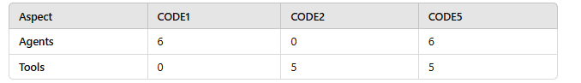
Here is the number of agents and tools in CODE1, CODE2, and CODE5, adesign choice
The choice between agents and tools often depends on the desired balance between modularity and adaptability.

Custom Prompts and ‘ZERO_SHOT_REACT_DESCRIPTION’
Custom prompts are essential for reasoning, enabling agents to follow the “Thought → Action → Action Input → Observation → Final Answer” framework. The ZERO_SHOT_REACT_DESCRIPTION approach in LangChain leverages this framework to dynamically decide which tool to invoke, based on input context and observations. This allows the system to adapt flexibly to diverse scenarios without retraining.
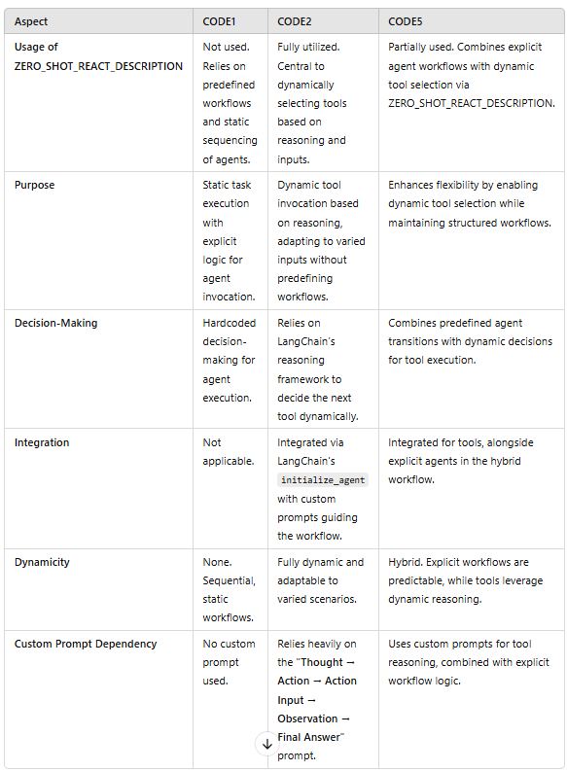
Comparison of the usage of “ZERO_SHOT_REACT_DESCRIPTION” in CODE1, CODE2, and CODE5
- CODE1: Does not use ZERO_SHOT_REACT_DESCRIPTION and relies on static workflows.
- CODE2: Fully leverages ZERO_SHOT_REACT_DESCRIPTION for dynamic and reasoning-driven tool selection.
- CODE5: Combines the best of both worlds, using ZERO_SHOT_REACT_DESCRIPTION for tools while maintaining explicit agent-based workflows.
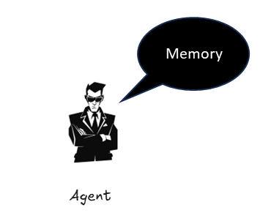

State Management
Agents and tools rely on a shared state to track progress, intermediate results, and workflow context. In structured systems like CODE1, the state is explicitly defined (e.g., GraphState) and manually updated. Dynamic systems like CODE2 and CODE5 use LangChain's StatefulMemory to handle state implicitly during tool execution.

Memory Class
A dedicated memory class (e.g., StatefulMemory) provides a persistent and centralized way to store, update, and retrieve state variables. While CODE1 lacks this, CODE2 and CODE5 use StatefulMemory for dynamic updates, ensuring state is consistently maintained across retries and workflows.

State Variables
Explicit variables in structured systems track predefined workflows (e.g., column_names, chain, metadata in CODE1). Dynamic systems allow tools to update variables based on observations, adapting to changing inputs.

Dynamicity of State
Structured agents follow fixed state transitions, while tools in dynamic systems interact with the state adaptively, as seen in CODE2 and CODE5.

Persistence
Memory ensures state is persisted beyond tool execution, enabling retries and error recovery.

Error Handling
Dynamic state systems inherently manage errors better, as persistent memory and retries maintain workflow integrity, while static systems require explicit error-handling logic.
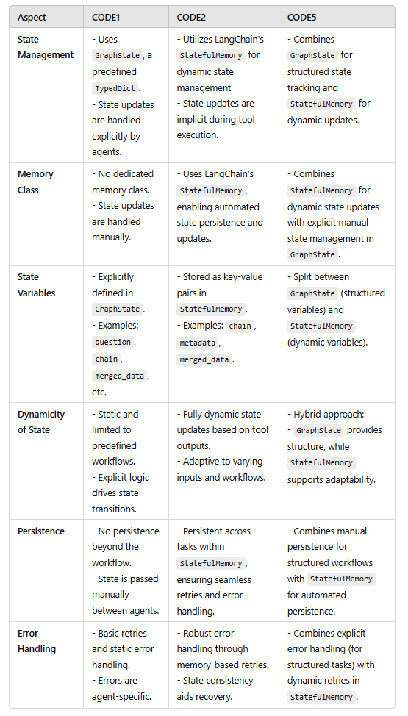
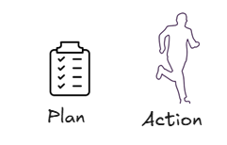

Actions and Planning in Agentic AI
In Agentic AI, Actions and Planning Mechanisms are the fundamental elements that drive task execution and optimize workflows, making the system efficient, adaptive, and resilient. Let’s explore these in more detail with examples from the codes.

Actions: The Core of Agent Behavior
What Are Actions?
- Actions are the atomic units of an agent’s behavior. They represent specific operations, such as invoking a tool, running a method, or executing a predefined task.
- Actions bridge decision-making (reasoning by agents) and execution (invoking tools or methods).
Key Characteristics:
- Task-Specific: Actions are designed to handle specific tasks like extracting entities, combining data, or creating chains.
- Dynamic Execution: In systems like CODE2 and CODE5, actions are dynamically chosen based on the system’s reasoning or state.
- Tool Invocation: Actions often involve invoking tools, such as the ChainCreation tool, which constructs a Named Entity Recognition (NER) pipeline in CODE2.
Example from CODE2:
- Thought: “I need to create an NER chain for the column names.”
- Action: Invoking the ChainCreation tool.
- Action Input: A list of column names with descriptions, such as {"CustomerName": "<Name of customer>", "PurchaseDate": "<Date of purchase>"}.
- Observation: A successfully created NER chain ready for use.
This action-based modularity allows flexibility, as agents can focus on “deciding what to do” while tools perform the actual tasks.

Planning Mechanisms: Optimizing Workflows
What Is Planning in Agentic AI? Planning refers to the process of sequencing and organizing actions to ensure efficient task execution. Effective planning ensures that agents execute the right actions in the right order, handle errors gracefully, and adapt to changing scenarios.
Key Goals of Planning:

Get Indrajit’s stories in your inbox
Join Medium for free to get updates from this writer.
Subscribe
Sequencing for Efficiency:
- Planning ensures actions are executed in a logical sequence to minimize redundant computations.
- Example: In CODE1, the DataCombinationAgent logically follows the EntityExtractionAgent because it depends on the extracted data.
Error Recovery:
- A well-planned system anticipates potential errors and includes retries or alternative paths.
- Example: In CODE5, retries are incorporated both for explicit agents (via manual logic) and tools (via LangChain memory).
Blending Structured and Adaptive Planning:
- Structured Planning: Predefined workflows, as seen in CODE1, where the sequence of agents is hardcoded.
- Adaptive Planning: Dynamic decision-making, as seen in CODE2 and CODE5, where actions are chosen based on reasoning.
- Hybrid Planning: CODE5 exemplifies this by using structured workflows for explicit agents and adaptive planning for tools.

Example of Planning in CODE5
Structured Workflow:
- The Global Agent invokes explicit agents (execute_column_name_agent, execute_chain_creation_agent, etc.) in a fixed sequence.
- This ensures predictable execution for tasks with dependencies.
Dynamic Planning:
- For tools like ChainCreation, planning dynamically selects the appropriate tool based on state and reasoning.
- Example: If the system encounters unexpected data, it might dynamically adjust to invoke MetadataExtraction for additional context.
Error Handling in Planning:
- If a task like EntityExtraction fails, the system retries using LangChain’s memory or predefined retry logic.
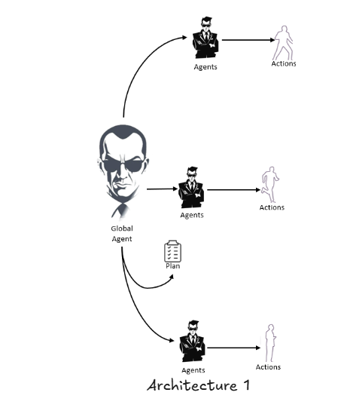

Comparing CODE1, CODE2, and CODE5

CODE1: A Structured Approach
- Design: Relies on class-based agents and a predefined workflow orchestrated by a Global Agent.
- Strengths:
- Transparent and easy to debug.
- Suitable for static workflows with predictable task sequences.
- Limitations:
- Lacks dynamic adaptability.
- No integration with LangChain for reasoning-based tool selection.

CODE2: Dynamic Flexibility with LangChain
- Design: Uses LangChain’s tools and memory to enable a dynamic, reasoning-driven approach.
- Strengths:
- Highly flexible, capable of selecting tools dynamically based on inputs and state.
- Employs custom prompts for reasoning, leveraging the ZERO_SHOT_REACT_DESCRIPTION agent type.
- Limitations:
- Heavily dependent on LangChain.
- Slightly abstract, making debugging more complex compared to CODE1.
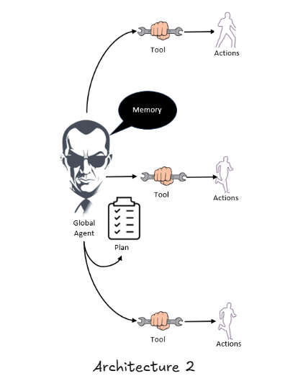

CODE5: Hybrid Design for Scalability
- Design: Combines the structured approach of CODE1 with the dynamic flexibility of CODE2.
- Strengths:
- Explicit agents ensure structured workflows, while LangChain tools offer adaptability.
- Suitable for scalable systems requiring both transparency and flexibility.
- Limitations:
- Complexity in blending static and dynamic components.
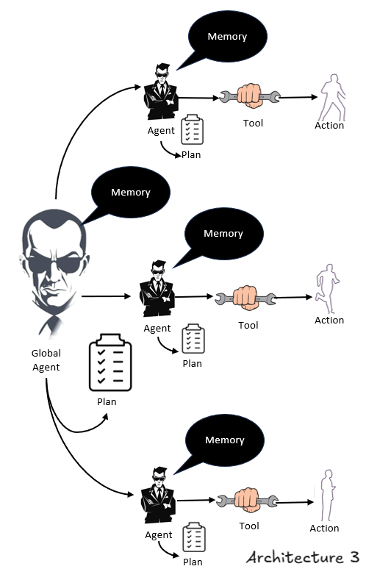
CODE1:
- Implements all tasks as explicit class-based agents, executed sequentially via a predefined workflow.
- Agents directly update the shared GraphState.
CODE2:
- All tasks are converted into LangChain tools, invoked dynamically using the ZERO_SHOT_REACT_DESCRIPTION reasoning framework.
- Relies on memory for maintaining state and seamless tool invocation.
CODE5:
- Uses explicit agents for workflow orchestration while relying on LangChain tools for task execution.
- Combines structured workflows from CODE1 and dynamic adaptability from CODE2.
This table highlights the evolution from the static, structured approach of CODE1 to the fully dynamic, tool-centric implementation in CODE2, and finally, the hybrid model in CODE5.
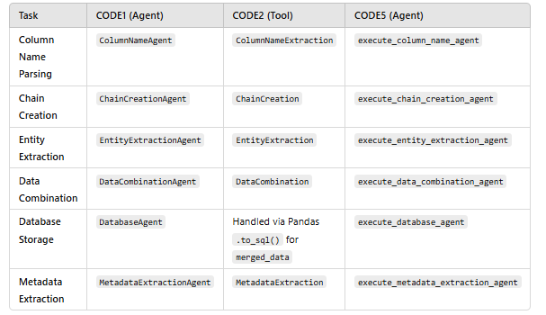

Converting Class-Based Agents to LangChain Tools
Class-based agents, as seen in structured systems like CODE1, are explicitly defined entities that perform specific tasks sequentially. They provide clear, modular logic for workflows, making them ideal for static systems with predictable task flows. However, this approach requires manual updates to state and explicit orchestration, limiting adaptability. Converting these agents into LangChain tools involves modularizing their functionality and leveraging LangChain’s dynamic execution framework. Each task becomes a callable tool with a defined input-output schema, enabling seamless invocation during runtime. For example, a ColumnNameAgent can be converted into a ColumnNameExtraction tool that takes column descriptors as input and returns a structured dictionary.
LangChain tools add flexibility by integrating with reasoning agents like ZERO_SHOT_REACT_DESCRIPTION, which dynamically select and execute tools based on input context and state. These reasoning agents replace the need for hardcoded workflows, enabling dynamic planning and execution. Additionally, LangChain’s memory (e.g., StatefulMemory) simplifies state management, ensuring persistence and consistency without explicit updates. The resulting system, as seen in CODE2 and CODE5, balances modularity and adaptability. By transitioning from class-based agents to LangChain tools and reasoning agents, workflows become more scalable and robust, capable of handling varied and complex inputs with minimal manual intervention.

Roles of Structured, Unstructured, and Vector Databases in an Agentic AI System
In the context of the diagram and workflow, each type of database plays a distinct but interconnected role:
Press enter or click to view image in full size
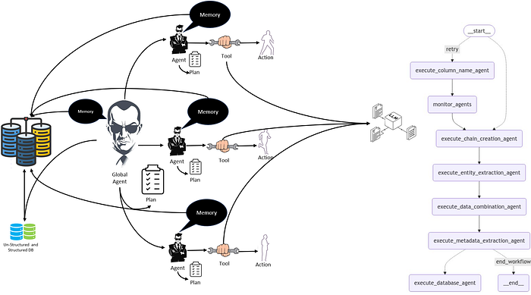
End to End implemenation with LLM

1. Structured Data
Definition:
- Structured data is highly organized and stored in tabular formats such as relational databases (e.g., PostgreSQL, MySQL). Examples include customer records, transaction logs, and inventory tables.
Role:
- Query and Retrieval: The Global Agent accesses structured databases to retrieve pre-organized data for tasks like matching, aggregation, or reporting.
- Baseline Knowledge: Acts as the foundational layer for deterministic queries like “Which customer purchased a specific product?” or “What is the total sales volume?”
- Integration: This data can feed directly into downstream tasks like merging with extracted entities or being used as reference data during LLM processing.
Example Use:
- A structured database might store customer purchase histories (CustomerName, PurchaseDate), which are retrieved and combined with extracted unstructured data for a comprehensive analysis.

2. Unstructured Data
Definition:
- Unstructured data includes textual, image, or audio data stored in document-based or NoSQL databases like Elasticsearch, MongoDB, or file repositories. Examples include customer reviews, emails, and social media posts.
Role:
- Input for LLM: Acts as raw input for the LLM, which processes the data for tasks like summarization, Named Entity Recognition (NER), or sentiment analysis.
- Entity Extraction: The extracted entities (e.g., names, dates, or sentiments) can be structured and merged with the structured database for enriched insights.
- Search and Retrieval: Provides full-text search capabilities to locate specific documents or phrases that are contextually relevant for the task.
Example Use:
- A database of customer reviews is fed into the LLM, which extracts structured entities like CustomerName and Sentiment for further processing.
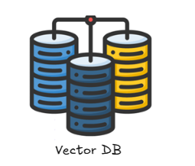

3. Vector Databases
Definition:
- A Vector Database (e.g., Pinecone, Weaviate, or Milvus) stores vectorized representations (embeddings) of data, enabling similarity searches and semantic queries. Examples include embeddings of product descriptions, customer reviews, or FAQ documents.
Role:
- Memory for Context Retrieval: Works as an external memory, allowing agents to retrieve relevant context by performing similarity searches on vectorized data.
- Semantic Matching: Facilitates advanced queries like “Find reviews similar to this one” or “Retrieve similar transactions for this customer.”
- Integration: Often complements unstructured data by storing its embeddings, enabling quick lookups during reasoning tasks.
Example Use:
- Customer reviews are vectorized, stored in a vector database, and retrieved during LLM queries to provide contextual information for a specific customer or sentiment pattern.

Comparing Roles
TypeStoragePrimary RoleExampleStructured DataRelational Databases (SQL)Query precise, pre-organized information.Retrieve all purchases by a customer from Customer and Orders tables for analysis.Unstructured DataDocument-based (NoSQL, Text)Provide raw inputs for LLM or full-text search capabilities.Analyze customer reviews stored in a NoSQL database to extract insights like sentiment or named entities.Vector DataVectorized Embedding StorageSemantic retrieval and similarity searches.Retrieve reviews with similar sentiment or tone by performing a cosine similarity search on vector embeddings stored in the vector database.
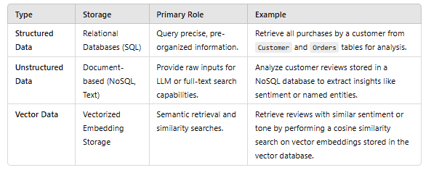

How They Work Together
Input:
- Structured Data: Provides the core reference or relational data.
- Unstructured Data: Supplies rich, free-form content that complements structured data.
Processing:
- Unstructured Data is passed through the LLM for feature extraction or semantic understanding.
- Extracted entities are merged with structured data for enriched datasets.
Retrieval:
- Vector Database enables advanced retrieval by storing embeddings, making contextual and similarity-based searches possible.
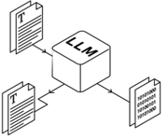

Role of LLMs in Architectures 1, 2, and 3 (formerly CODE1, CODE2, CODE5)
Last but not the least, Large Language Models (LLMs) like Llama play a pivotal role in enabling reasoning, adaptability, and automation across Architectures 1, 2, and 3. Their integration enhances the ability to process natural language inputs, extract insights, and make decisions dynamically.
Architecture 1 (CODE1):
- The LLM is used explicitly within agents like ChainCreationAgent to set up a Named Entity Recognition (NER) pipeline.
- Agents rely on predefined prompts and workflows to invoke the LLM for extracting entities from unstructured data such as review texts.
- While the LLM performs well in task execution, the integration is rigid, with limited adaptability to changing contexts.
Architecture 2 (CODE2):
- The LLM is leveraged dynamically through LangChain tools like ChainCreation and EntityExtraction.
- Using ZERO_SHOT_REACT_DESCRIPTION, the LLM reasons about the task and decides which tool to invoke, adapting to various inputs.
- This approach maximizes flexibility and allows the system to handle unforeseen scenarios without predefined workflows.
Architecture 3 (CODE5):
- Combines explicit agents with tools powered by LLMs, achieving a hybrid model.
- LLMs are dynamically invoked by tools and explicitly integrated into agents for structured workflows, ensuring scalability and flexibility.
Across all architectures, LLMs empower the system to process natural language, extract insights, and dynamically adapt to real-world tasks.

Conclusion
Designing robust Agentic AI systems requires balancing structure, adaptability, and scalability to meet the demands of modern workflows. CODE1, CODE2, and CODE5 highlight different approaches to implementing these systems, showcasing how agents, tools, memory, and planning mechanisms can be tailored to diverse scenarios.
CODE1 demonstrates the value of structured workflows using explicit agents. This approach is transparent, predictable, and easy to debug, making it ideal for tasks with well-defined sequences. However, its lack of adaptability limits its application in dynamic environments.
CODE2, on the other hand, embraces flexibility and reasoning. By leveraging LangChain’s tools and ZERO_SHOT_REACT_DESCRIPTION, it dynamically selects tools based on context, enabling the system to adapt to varying inputs and scenarios. This adaptability, while powerful, can make debugging more complex due to its abstracted logic.
CODE5 combines the strengths of both approaches, creating a hybrid system. It uses explicit agents for structured tasks and LangChain tools for dynamic adaptability, providing scalability and transparency in complex workflows.
As Agentic AI continues to evolve, integrating structured planning, dynamic reasoning, and efficient state management will remain key. Systems like CODE5 offer a glimpse into how these principles can work together to create intelligent, scalable, and future-ready AI solutions.

